THE 22ND IEEE INTERNATIONAL CONFERENCE ON INDUSTRIAL INFORMATICS (INDIN) INDIN 2024
AUGUST 17-20, 2024, BEIJING, BJ, CHINA

Special Session on

“Human Factors in Decision-Making, Planning and Control Technologies of Intelligent Vehicles”

Principal Organizer(s):

Organized by

- Guodong Yin (ygd@seu.edu.cn), Professor, Southeast University
- Jinxiang Wang (wangjx@seu.edu.cn), Associate Professor, Southeast University
- Hongliang Wang (whl@njust.edu.cn), Associate Professor, Nanjing University of Science and Technology
- Yongjun Yan (yanyj@njust.edu.cn), Assistant Professor, Nanjing University of Science and Technology

Call for Papers
Theme: This special session aims to provide up-to-date research concepts, theoretical findings, and practical solutions on considering human factors in decision-making, planning, and control technologies for intelligent vehicles, which could help to improve the driving safety and ride comfort of intelligent vehicles.

Topics of interest include, but are not limited to:

  - Application of AI and machine learning for autonomous driving
  - Personalized decision-making and trajectory planning
  - Behavior prediction of human-driven vehicles and pedestrians
  - Multi-vehicle interaction in complex environments mixed with human-driven and autonomous vehicles
  - Multi-vehicle cooperative trajectory planning in mixed driving environments
  - Drivers and passengers trust analysis and assessment of intelligent vehicles
  - Driver behavior analysis in driver-automation shared control
  - Personalized Advanced Driver Assistance Systems (ADAS)
  - Human-machine cooperative decision-making and control technology
  - Personalized steer, brake and drive systems based on driving style identification

- Potential Contributing Authors (names and emails):

Jinhao Liang | National University of Singapore | jh.liang@nus.edu.sg,
Zhenwu Fang | National University of Singapore | zhenwu.fang@u.nus.edu
Sizhe Cheng | Southeast university | 220230365@seu.edu.cn
Shuo Bai | Southeast university | 230228068@seu.edu.cn
Jingyu Hu | Southeast university | hujy19971224@163.com
Kuoran Zhang | Taiyuan University of Science and Technology | zhangkuoran@tyust.edu.cn
Xian Li | Nanjing University of Science and Technology | lixian@njust.edu.cn
Dingge Fan | Nanjing University of Science and Technology | 572761426@qq.com
Pengyu Xue | Nanjing University of Science and Technology | xpy_njust@163.com

- Potential Reviewers (names and emails):

Zhongxu Hu | Center for Advanced Intelligence Project (AIP)  /RIKEN/Japan | zhongxu.hu@riken.jp
Beatriz Lopez Boada | University Carlos III de Madrid | bboada@ing.uc3m.es
Zhaojian Li | Michigan State University | lizhaoj1@egr.msu.edu
Fengjiao Zhang | Changzhou Vocational Institute of Mechatronic Technology | zfj2185@czimt.edu.cn
Yan Wang | Nanyang Technological University | yanjack.wang@polyu.edu.hk

Information of Principal Organizers

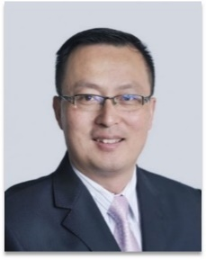
Guodong Yin (Senior Member, IEEE) received Ph.D. degree in vehicle engineering from Southeast University, Nanjing, China, in 2007. He is currently a Professor at the School of Mechanical Engineering, Southeast University, Nanjing, China. His current research interests include vehicle dynamics and control, connected vehicles, and multi-agent control, where he has published a monograph and contributed three book chapters, over 150 papers, and obtained 25 granted patents.

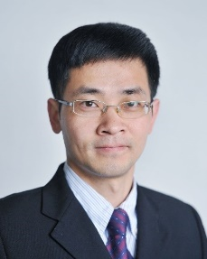
Jinxiang Wang (Member, IEEE) received the B.S. degree in mechanical engineering and automation and the Ph.D. degree in vehicle engineering from Southeast University, Nanjing, China, in 2002 and 2010, respectively. From 2014 to 2015, he was a Visiting Research Scholar with the Department of Mechanical and Aerospace Engineering, The Ohio State University, Columbus, OH, USA. He is currently an Associate Professor with the School of Mechanical Engineering, Southeast University, Nanjing. His research interests include vehicle dynamics and control, assisted-driving system, and control on autonomous vehicles.

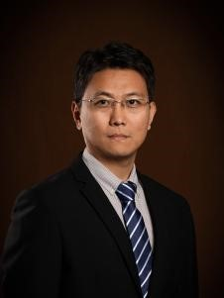
Hongliang Wang received the S.E. degree and the Ph.D. degree, both in vehicle engineering from Beijing Institute of Technology, Beijing, China, in 2004 and 2010, respectively. He is currently an Associate Professor of Safety and Intelligence of Vehicle equipment Research Center, Nanjing University of Science and Technology, Nanjing, China, focusing on research of control technology of intelligent vehicle chassis, vehicle dynamics, etc. He has visited University of Waterloo, Canada, in 2016.

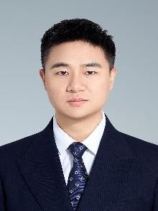
Yongjun Yan received an M.S. degree and Ph.D. degree in vehicle engineering from Southeast University, Nanjing, China, in 2020 and 2024, respectively. He is currently a Lecturer with the School of Mechanical Engineering, Nanjing University of Science and Technology, Nanjing. His research interests include vehicle dynamics and control, automotive active safety control, intelligent vehicle decision-making and control, and personalized driving. As the first
author, he has published over 10 SCI/EI academic papers in top journals such as IEEE TITS, TIV, TMECH, TVT), etc. Additionally, he has been granted or accepted over 20 national invention patents, and has presented his work at conferences such as IEEE Intelligent Vehicles Symposium.

